VII Esocite

Jornadas Latino-Americanas de Estudos Sociais das Ciências e das Tecnologias

Temas:
4. Análisis de redes inter-institucionales
40. Ciencias, tecnologías y fronteras y reorganizaciones interdisciplinarias
96. Procesos de generación y acumulación/des-acumulación de capacidades cognitivas
102. Redes socio-cognitivas

Changing views of the success of interdisciplinary research

Por:
Cecilia Hidalgo, Anthropologist, Master in Philosophy, FFyL-UBA, Full Professor. Argentina. <chidalgo@filo.uba.ar>

Claudia E. Natenzon, Geographer. PhD in Geography, FFyL-UBA/ FLACSO, Full Professor. Argentina. <natenzon@filo.uba.ar>

Guillermo Podestá. Agronomist. PhD in Biological Oceanography. Rosenstiel School of Marine & Atmospheric Science, University of Miami. Research Profesor. EEUU. <gpodesta@rsmas.miami.edu>

Kenny Broad. Ecological Anthropologist. PhD in Anthropology. Division of Marine Affairs and Policy, Rosenstiel School of Marine & Atmospheric Science, University of Miami. EEUU. <kbroad@rsmas.miami.edu>

Changing views of the success of interdisciplinary research

- Introduction

The paper reports results from a case study of a multi-disciplinary, multi-institutional, multi-national research team convened to address a highly complex problem with societal relevance: to understand and model adaptive management of agricultural ecosystems in the Pampas of central-eastern Argentina in response to climate variability and other sources of risk and uncertainty.

In identifying factors that foster or impede the production of interdisciplinary knowledge, including the participation of stakeholders, the authors underline the importance of research team group dynamics and shared social goals. Thus, the analysis focuses on the shifting perspectives and metrics of “success” held by participants at three specific stages of the collaboration process: the project start, an intermediate stage (about two years into a three-year project) and the end.

Changing representations of success are related to the performance of individual participants or research units during the development of the project, namely that of (a) researchers that formed highly-productive teams with frequent and intensive interactions, (b) those that organized themselves around the project coordinator, and (c) those who could not deeply engage in collaborative production of knowledge, searching refuge in more comfortable and familiar processes of individual production for disciplinary journals or institutions.

Changing views of success may also be related to a tight project schedule, the pressure to obtain useful and tangible results in a short timeframe, unanticipated personal issues among some team members, and the pressure to produce high-impact publications. Standards of integration and effectiveness were higher among those individuals or groups who developed a focused collaboration. Less integrated participants lowered their own initial, self-defined standards for successful interdisciplinary interaction, valuing more abstract outcomes such as the mere establishment and consolidation of channels of mutual learning and communication among groups and researchers.

- To complex scientific problems, interdisciplinary teams+ stakeholders + reflexivity

Interdisciplinary teams constitute an emerging pattern for organizing scientific and technological research (Boix Mansilla et alt. 2006; Rothen 2002; Hidalgo 2005; Luna &Velasco 2006; Hidalgo, Natenzon, Podesta 2007). It is common sense nowadays to accept that addressing and modeling of complex problems can be done only by pulling together insights and methods from many disciplines (Nissani 1997). Furthermore, in search for scientific and social relevance taking into account diversity of knowledge and value criteria, the inclusion of stakeholders in scientific projects as full members or peers is becoming more and more frequent (Funtowicz & Ravetz 1992, Natenzon & Funtowicz 2004). Reflexivity on the process, needed to identify factors that foster or impede the production of interdisciplinary knowledge, including the participation of stakeholders, is also becoming an emergent component of the projects (Hidalgo 2005). Easily constructed as a way to address complexity and avoid the dominant disciplinary fragmentation of the sciences, integrative arrangements of scientific work expand, actively promoted by funding agencies. However, the cognitive and scientific challenges posed by this type of collaborative production of knowledge have not been exhaustively studied. In particular, case studies of multi-disciplinary, multi-institutional, multi-national research teams are rare. Although there are not explicit criteria on the issue, nobody would accept the kind of interdisciplinarity Dan Sperber (2001) calls “cosmetic”, where the actual scientific content consists just in the juxtaposition of monodisciplinary projects and results.

- The case studied

This paper aims to provide elements for a discussion of the issue on a non a priori or “naturalized” (Giere 1988) basis, focusing the analysis on the performance of an interdisciplinary team convened to address a highly complex problem with societal relevance: to understand and model decision-making in agricultural production in the Pampas of central-eastern Argentina, including adaptation and learning, in the light of climate variability, technological innovation and other drivers. It aims to present a fine grained study of the representations of the “successful interdisciplinary practice” of a scientific team that included as a particular objective to conduct a reflective analysis of the challenges of interdisciplinary, multiple-place collaboration and stakeholder involvement in integrative science.

Research that falls across disciplines meets overcoming challenges and impediments associated with collaborative work in interdisciplinary settings (Nissani, 1997; Pohl, 2005). Obstacles are many and diverse in nature: an adequate composition of the team, language barriers, data hierarchies, applied and theoretical outcomes, varied academic incentives, multi-sited research, not to mention disciplinary biases, institutional and personality issues, among others. We present changing views held by the participants of this project as concerns these obstacles and the desirable outcomes of collaboration.

We describe the dynamics of the interdisciplinary research team, focusing on representations of “success” at three specific stages of the collaboration process: the project start, an intermediate stage (about two years into a three-year project) and the end. Although participants made a continuous effort to produce integrated knowledge and not just a collection of disperse and separate findings, as time passed they expressed shifting perspectives and metrics of “success”. We analyze and interpret them in connection with the collaborative performance of individual participants or research units along the development of the project.

- Methodology:

Current approaches work mainly on the basis of interviews, archival analysis and focus groups (Boix Mansilla 2006, Luna & Velasco 2006, Jeffrey 2003). Our work is organized around another qualitative methodology -participant observation- facilitated by the interest of the team studied in self-reflection. However, focused interviews and analysis of different kinds of tangible findings and results (peer reviewed papers, book chapters and one time publications, meeting abstracts, meeting presentations, outreach and theses) were complementary. The process of collective and participatory modeling of this diverse, yet well-balanced team of investigators, stakeholders and outreach specialists has been registered and monitored along three years. Knowledge exchange and network formation were registered through a follow up protocol and described using Ucinet tools. (See Figure 1)

III. Three stages of the interdisciplinary research team

- The project start

The initial composition of the research team reflected the broad spectrum of talents deemed necessary by project designers to attack highly complex problems with societal relevance, including commitment with a self reflexive component of the work in progress. Based on a successful previous cooperation experience around less demanding problems, a great heterogeneity of the group was conceived as a potentiality. Indeed, the team showed a remarkable quantitative and qualitative balance of its 30 members: formed as mathematicians, statisticians, physicists, climatologists, biologists, psychologists, economists, geographers, anthropologists, sociologists, agronomists they added different and complementary theoretical and operational abilities. Twelve institutions were involved: 7 universities, 3 governmental organizations, 2 non governmental organizations; 6 were Argentine and 6 American; 7 were public and 5 private. A hallmark of the team was the participation of non academic stakeholders as full peers.

But building a productive interdisciplinary team is not simply recruiting one expert from each needed discipline: it involves researchers able to work in unknown problems and across familiar boundaries. A diverse, yet well-balanced team of investigators and outreach specialists that matches the range of objectives targeted in integrative science projects does not assure success of interdisciplinary collaboration, especially when high standards of success are held.

In our case, a rich set of perspectives resulted from the composition of the selected team, making it a specially promising ground for reflection: (a) linked modelling approaches for generation of climate and technology scenarios and assessment of decision outcomes, (b) experiments on decision-making and behaviour, including explicit consideration of adaptation and learning, and (c) participatory research that draws on contextual knowledge and stakeholders’ experiences and preferences. Given the strong focus on understanding the dynamics of human behaviour and decisions, particularly with respect to the twin problems of choice and uncertainty in the context of a real-world complex natural/human system, special attention was paid to the active involvement of farmers and operational producers of climate information.

The initial network assumed as possible the most stringent dimensions of success of integrative research. Participants believed they could overcome all the difficulties and obstacles. The only remarkable line of differentiation showed stakeholders and members of non governmental organizations were heavily outreach oriented while academics remained highly interested in publications and modelling.
The following collective synthesis of definitions of interdisciplinary research (IR) is eloquent about the enthusiasm and optimism they shared at a starting time when all obstacles were minimized.

Collective synthesis of definitions of IR (USA February 2005)

Poses, addresses | Requires
Challenging Goals | Translation
Integrative | Synergy | Produces
Focuses Complex Problems | Developing a:  - Common vocabulary  - Common framework  - Common methodology | - New knowledge  - Synthesizes  - Core knowledge  - Ever-increasing amounts of knowledge, information and skills.
Broader | Collaborative work
Solves Relevant | Mutual learning/influencing | Solves
Significant | Rigorous disciplinary methods | - Complex systemic/integrated problems
 | Work across disciplinary lines

At start everything seemed possible, participants´ representation of “success”/ “failure” was conceived in an abstract and romantic way. They said they would achieve “Publications; Friendship; An integrated model; Policy prescriptions; Changing Farmer/Household Behavior; Outreach Products; New Knowledge; Global harmony”. They felt so enthusiastic and humorous that they even mentioned that IR could make them earn “Frequent flyer miles and more money”

b) Intermediate interdisciplinary network

Although there were no groupings of project participants along a single dimension (e.g., by discipline, by institution, by career stage), the team tended to show two kinds of structures which prevailed at different moments: (a) researchers that formed highly-productive teams with frequent and intensive interactions, and (b) individual researchers or units that organized themselves around the project coordinator. This dual structure may have responded, to a great extent, to a tight project schedule, the pressure to obtain useful and tangible results in a short timeframe, and the need to produce a number of high-impact publications. (See again Figure 1).

All these pressures may have contributed to reducing team integration and effectiveness. Instead, a focused collaboration developed while participants organized around the project coordinator tended to draw back to more comfortable and familiar processes of individual production for disciplinary journals or institutions.

Self reflection on the progress of collaborative work presented in a plenary meeting made clear that some participants had found problems in interaction and were worried about the time required to write a collective paper, to discuss with others things that could be “closed” without much objection or to attend meetings each time more diverse and frequent. That plenary meeting posed as objectives to make each participant or subgroup explain other groups in an understandable manner how they planned to enhance interaction and the integration of activities at least with one or two other groups.

Disciplinary value conflicts, personality issues, compromises and negotiations were not formulated in an explicit way, but started to emerge disguised as diverse timing expectations or different ideas about how much simplification or realistic complexity to introduce in the global model. Romanticism was over. Obstacles were now recognized as concrete and specific.

The following table constitutes an example of the collective synthesis the team produced when asked for a comparison of their own ideas of success at the beginning of the research and at that intermediate stage. The table contents were obtained in interviews and conversations, and were then presented for collective discussion and comparison.

Collective synthesis of ideas of success (Argentina March 2006)

 | Project beginning | Advances | Tangible products/ outcomes | Problems faced
Problems to solve and objectives posed promote collaborative interaction. | “New avenues have been opened”  “The project comprehends us all: at the time to formulate the model, to adjust and calibrate it, to validate it, to introduce realism into it…” | “Collective papers ‘closed’ or almost closed” | Papers take time  .  Realistic models take time  Data bases must be complete | “ It is a waste of time to wait till others have works ‘closed’ or to discuss every result before publishing”
Reciprocal learning | “Diversity presupposes  different ideas on what we are doing”  “Redundancy is important. We have to repeat things several times, be they conceptual or organizational, till they are understood and accepted”. | “Everybody must feel free to share their drafs with others”  “We must collaborate, try to understand what others have done, and intervene following his/her own experience ” | Meetings/ sharings each time more frequent. | “It is a waste not to have consulted the other groups to do this work”  “Permeability y tolerance as concerns others’ points of view”.
Collective solving of problems (no ad hoc) | “Our outcome must be an emergent property to which we have all collectively contributed” | Consolidation of productive sub groups around different objectives. | “The complete team must act as an internal consultant or reviewer” | Emergent properties are recognized and visualized mainly just by the coordinator.
Data collection and sistematization useful and relevant for everybody | “At the beginning models do not need to be overcomplex. Realism is introduced gradually through testing”  “The model achieves a realistic management of uncertainty”. | “We have to produce inputs useful for other groups and institutions”. | -Little publications (presentations, lectures, posters)  Internacional publications of high scientific impact  Special issues (not books) | Timing differences  Different units of analysis: individuals, institutions,etc.
Tension simplify/make more complex and realistic

Different ideas about the convenience of modeling: Is everything modelizable?
Results carry a substantial difference when political decisions are involved | It is of a crucial importance that results be relevant to decision making.  We will succeed only if we achieve an advanced conceptual model of a complex human and natural system | If publications are produced, better. But it is not the most relevant thing for us. We must reach people’s needs with good services and products. | Outreach results: to improve known products and to create new ones.  To show farmers opportunities and dangers.  To invent new parameters and indexes | Outreach results involve many heterogeneous agents  Educational objectives are very important.

Shifting ideas of success held by participants were not casual. Those researchers that formed highly-productive teams with frequent and intensive interactions kept high standards of integration and effectiveness. For them “success” still meant great research, educational and outreach efforts that ought to be evaluated. For education, two important metrics were accepted:
(a) number of project outputs (papers, abstracts, reports, etc.) authored by individual researchers or research units, and

(b) number of outputs involving other members of the team studied and junior scholars from more than one institution, reflecting success in fostering networking. As concerns outreach, communication with stakeholders and governmental organizations and the production of services, materials and/or no strictly academic products were considered a priority. Finally,

(c) teaching through research was seen as a crucial way to form versatile scientists able to work well in multidisciplinary and cross-cultural teams, use a diverse suite of models and tools, and communicate complex ideas to decision-makers.

Researchers that organized themselves around the project coordinator or worked in isolation charged him with a double burden: cognitive (given his mastery of the general intellectual strategy) and entrepreneurial/ administrative (urging him to take an active leadership in cases where cooperation had not emerged spontaneously).

It is important to note that intermediate stages of research are generally those when teams explore and identify the basis for their continuity in future projects. That is why in our case after designing arrangements to deepen processes of integration (i.e. several devices to share partial results and enhance crossing collaboration on specific issues), a process of separation of the team of those reluctant to cooperate begun.

c) The end of the project

By the end of the project the collaborative structure of the team consolidated the collaboration of some productive cliques, with a high overall intensity of accumulated interactions measured on the basis of tangible products (506 from co-authored publications; 2.218 if collective publications of 20 o more authors are included). Papers or presentations that were supposedly written by all the team may not have implied effective collaboration on the text but just the recognition of the complementary and collective work of the research group.

A non expected result showed the intensification of cooperation among members of the same institution. Units that had worked in isolation or connected mainly with agents or institutions external to the team ended their work without open conflict, and simply they were not included in the new projects of the group.

When asked again about their criteria of success in interdisciplinary contexts, less integrated participants showed an accommodation of their representations to their new situation. They lowered their own initial, self-defined standards of successful interdisciplinary interaction, valuing more abstract outcomes such as the mere establishment and consolidation of channels of mutual learning and communication among groups and researchers. Their epistemic measures of the acceptability of the results of interdisciplinary interaction pointed to intangible goods that, although very important, function as preconditions of other types of achievement. Obviously, had the members of the team produced only mutual learning or renewed relationships among researchers and stakeholders, their future projects would have never been supported.

On the contrary, members of collaborative cliques pointed to new challenging realms of acceptability of interdisciplinary results, confirming Boix-Mansilla & Gardner (2006) ideas on the centrality of three main epistemic “symptoms” of quality of interdisciplinary work: consistency with antecedent disciplinary criteria, balance among perspectives articulated and woven together and the effectiveness with which intellectual products (the model, publications, services, theses, etc.) advances understanding and inquiry.

- Conclusion

To generate criteria for an epistemic evaluation of “success” of interdisciplinary work is not a simple task. Although we are conscious that we are dealing with a single case that may be a too small sample for generalizable lessons, we hope to contribute to the formulation of those criteria on a non a priori basis, describing a kind of epistemic dynamics that could yield enhanced understanding of ID collaboration.
Participants of the increasing number of ID teams and funding agencies are interested in the formulation of reasonable assessment categories of this type of knowledge production. Our paper has showed changing views of success held by members of a very productive ID team, where shifts are related to their disparate disposition and capability of actual cooperation. Those who interacted more, increased their expectations about relevant collective outcomes. Those who could not properly work with others, lowered them to fit just with mutual learning and understanding.
Stakeholder involvement in the research process from its formulation to the validation of its outcomes had multiple advantages. They were -with participants from NGOs- those most prone to collaborate and intervene in collective activities, always fostering learning and pointing to high standards and criteria of success. We may say that in the case studied what prevailed as a source of conflict had to do with disparate priorities, expectations and timing of scholars, not of stakeholders. Academics made efforts to produce novel work, to avoid work in isolation but intentions are not enough when time schedules ask for tangible results.

Acknowledgements
This research was supported by UBACYT, Argentina, and the National Science Foundation, USA: NSF Grant BCS-0410348, project "Understanding and Modeling the Scope for Adaptive Management in Agroecosystems in the Pampas in Response to Interannual and Decadal Climate Variability and Other Risk Factors", Programme “Biocomplexity in the Environment Initiative, Coupled Natural and Human Systems”

References:

Banús, Eduardo M. 2006 “La estrategia de redes de conocimiento adoptada por UNESCO“

Boix Mansilla, Veronica & Howard Gardner. 2006. Assessing Interdisciplinary Work at the Frontier. An empirical exploration of 'symptoms of quality'. 7 p. See: http://www.interdisciplines.org/interdisciplinarity/papers/6

Funtowicz, Silvio y Ravetz, Jerome 1992 ”Three types of risk assessment and the emergence of post normal science”, en Sheldom Krimsky y David Gloding (eds.) Social Theories of Risk Praeger, London,pp.251-273.

Giere, Ronald 1988 Explaining Science: a cognitive approach. Chicago: University of Chicago Press.

Hidalgo, C. 2005. “Lo local y lo global en las prácticas científicas: diversidad etnográfica en peligro”. In: Hernandez, V and C. Hidalgo (eds.), Nuevos campos antropológicos en la globalización. Ediciones Sociedad Argentina de Antropología, Buenos Aires.

Hidalgo, Cecilia. 2006. “Reflexividades”. En: Cuadernos de Antropología Social 23. Facultad de Filosofía y Letras, Universidad de Buenos Aires. Buenos Aires

Hidalgo, C., Claudia Natenzon y Guillermo Podestá, “Interdisciplina: construcción de conocimiento en un proyecto internacional sobre variabilidad climática y agricultura”, Revista Iberoamericana de Ciencia, Tecnología y Sociedad Nº 9, vol.3, 2007: 53-68

Luna, Matilde y José Luis Velasco. 2006. “Redes de Conocimiento: principios de coordinación y mecanismos de integración”. En: Redes de Conocimiento. Construcción, dinámica y gestión. Mario Albornoz y Claudio Alfaraz (eds.). Buenos Aires, RICYD/CYTED/UNESCO (17-40).

Natenzon, Claudia E. y Silvio Funtowicz. 2003. “Ciencia, gobierno y participación ciudadana”. En: La democratización de la ciencia y la tecnología. José Antonio López Cerezo, editor. San Sebastián, EREIN (51-76). Colección Poliedro: Ciencia, tecnología, cultura, sociedad.
Nisanni, Monti 1997 “Ten Cheers for Interdisciplinarity: The Case for Interdisciplinary Knowledge and Research”,The Social Science Journal, Volume 34, Number 2, (201-216), Wayne State University, JA! Press Inc.

Pohl, Christian 2005 “Transdisciplinary collaboration in environmental research”. In: Futures 37 (1159-1178).

Sperber, Dan 2001 “Rethinking interdisciplinarity” www.interdisciplines.org

FIG. 1: THREE STAGES OF THE COLLABORATION PROCESS

Initial stage network  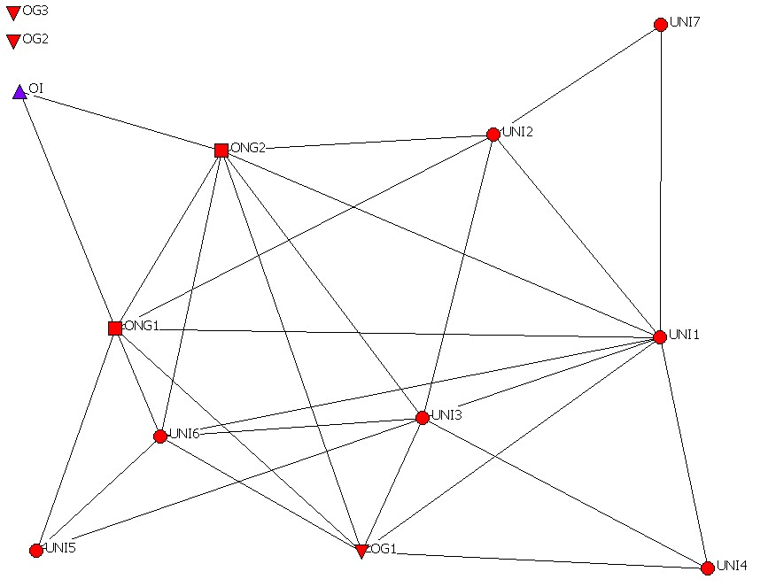  Source: Interviews | Middle stage network  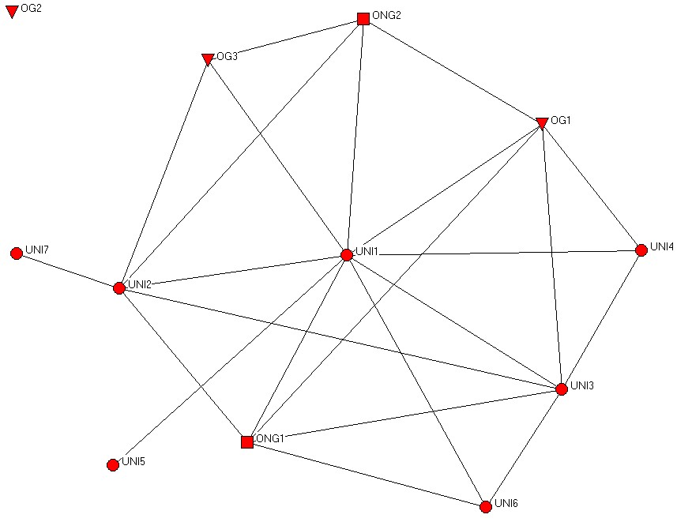  Source: Interviews | Final stage network  Source: Interviews, without Objective 8th | Final stage network (a)  Source: Publications, no multi authors
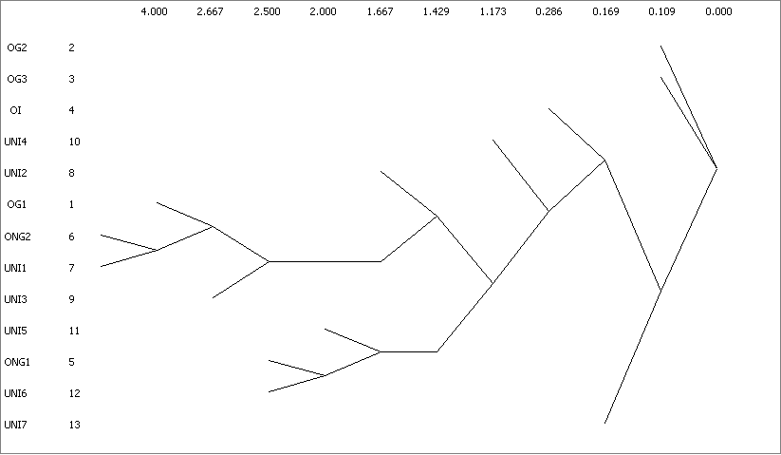 | 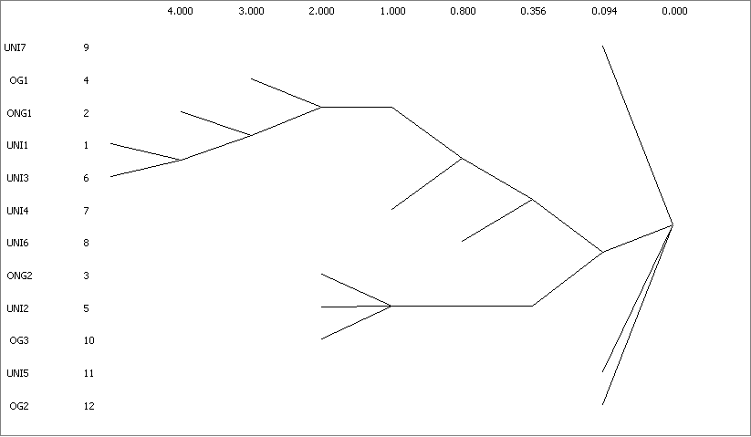 | 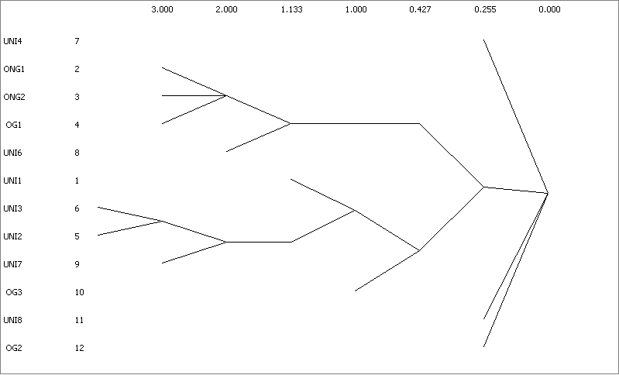 | 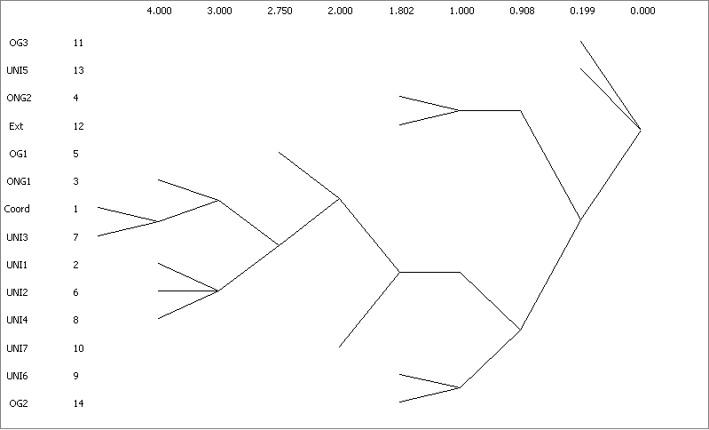

SOURCE: Personal elaboration using ARS UCINET.

